**Project Title: Employing Deep Learning To Detect Face Mask Usage Among Somali HealthCare Staff**

**Abdijalil Hussein Nor Ahmed Hashim Ahmed**

A report submitted in part fulfilment of the degree of

**COMPUTER SCIENCE**

**Supervisor:** Ubaid Mohamed Daahir



Department of Computer Science

Faculty of computing, Simad University

Jan 2025

# DECLARATION

“I declare that the following is my own work and does not contain any unacknowledged work from any other sources. This project was undertaken to fulfill the requirements of the bachelor’s degree program in Computer Science/Information Technology/Graphics, and Multimedia at Simad University”.

Signature : ……………………………

Name : ……………………………

Date : ……………………….……

# Acknowledgements

Thanks to Allah for giving us the power and help to accomplish this research. Without the grace of Allah, we would not be able to accomplish this work. We would like to thank our parents very much for their patience, motivation, and continued support. We also extend our thanks to all our family members for their motivation and support. We are grateful to our supervisor, Ubaid Mohamed Dahir, for his enormous support, valuable guide, and assistance throughout the work of his research. special thanks to our beloved families. Who has been the source of our inspiration.

# Abstract

This research investigates the creation and application of a deep learning-based system for identifying when medical personnel are wearing face masks. Ensuring appropriate adherence to mask-wearing standards in hospital facilities became crucial in response to the problems presented by the COVID-19 pandemic. To achieve precise real-time face mask detection, the system makes use of sophisticated neural networks including Convolutional Neural Networks (CNNs) and object detection frameworks like MobileNetV2 and YOLOv8. Safety precautions can be improved by automating ongoing compliance assessments through the integration of these models into healthcare monitoring systems. Although issues like privacy concerns and environmental factors still exist, the results show that deep learning models can accurately classify masked, unmasked, and poorly masked faces. Enhancing robustness, addressing ethical issues, and incorporating more comprehensive health monitoring tools are the goals of future developments.

Table of Contents

DECLARATION 2

Acknowledgements 3

Abstract 4

CHAPTER 1 7

**1.0. Introduction 7**

**1.1. Background of the study 8**

**1.2. Problem Statement 9**

**1.2 Objectives 10**

**1.2.1. General objective 10**

**1.2.2. Specific objective 11**

**1.3 SCOPE OF THE STUDY 11**

**1.4 Significance of the study 12**

CHAPTER 2 14

LITERATURE REVIEW 14

2.0 Introduction 14

2.1.0 Related work 14

2.2 Deep Learning-Based Approaches 17

2.4 Challenges in Face Mask Detection 18

2.5 Research Gap 18

2.5.1 Lack of Region-Specific Datasets 18

2.5.2 Infrastructure and Computational Constraints 19

2.5.3 Adaptability to Real-World Healthcare Environments 19

2.6 Chapter Summary 20

CHAPTER THREE: 21

**RESEARCH METHODOLOGY 21**

3.0 Overview 21

3.1 Research Desing 22

3.2 Dataset Building 23

3.3 Data collection 24

3.4 Preprocessing 25

3.5 feature extraction 26

3.6 Model Design and Development 27

3.7 Model Training 27

3.7.1 Evaluation 28

**3.8 Classification Model 28**

3.9 Research Plan 29

3.9.1 Time Schedule for Action Plan 29

References 30

# CHAPTER 1

## Introduction

In healthcare settings, the importance of adhering to personal protective equipment (PPE) protocols, particularly wearing masks, cannot be overstated, The current global health crisishas brought to memory how masks can play an indefinable part in the prevention of transmissible diseases-from those caused by the ongoing pandemic caused by COVID-19. The frontline who take charge of patient care, their risk is higher in exposure from viruses and other organisms. That should be the major reason for ensuring wearing of masks by healthcare staff consistently.

However, the "traditional" ways to monitor mask compliance in such large healthcare facilities include manual checkups or observation by security personnel and are also inefficient, error-prone, and time-consuming. That means there is a need for an automated, scalable, and sound system by which mask-wearing could be constantly monitored among healthcare workers. Deep learning, especially in computer vision, offers a very good chance for solving this problem with automatic mask detection in real-time.

This will design a deep learning-based mask detection system that can recognize mask-wearing healthcare staff in hospitals using the visual data recorded from the cameras set up within the health settings.

## Background of the study

The COVID‑19 pandemic significantly increased tjhhe reliance on face masks to mitigate the spread of the virus and other infectious diseases, particularly in high‑risk areas such as hospitals. Healthcare workers must adhere to stringent mask usage regulations to ensure the safety of both patients and themselves, although human error remains a persistent challenge (Abdirahman et al., 2023).

Fortunately, advanced vision computing technologies have enabled automated, real‑time monitoring of mask adherence. Several studies have demonstrated the potential of deep learning techniques to facilitate this process in dynamic healthcare environments (Mohana et al., 2022; Boulila et al., 2021). Modern deep learning‑based approaches—especially Convolutional Neural Networks (CNNs)—have shown notable success in object detection tasks, including both facial and mask detection (Muhammad et al., 2021). These models can achieve high accuracy in distinguishing between masked and unmasked faces when trained on sufficiently large datasets (Abdirahman et al., 2023; Loey et al., 2021). Comparative analyses of various CNN architectures—such as MobileNet, ResNet50, InceptionV3, and VGG19—have revealed that models like ResNet50 can reach precision rates exceeding 98% in mask detection tasks (Muhammad et al., 2021; Abdirahman et al., 2023).

Despite these advancements, real‑world challenges persist. Variations in lighting, facial orientation, and complex backgrounds can adversely affect detection performance, while obstructions from medical equipment, facial hair, or eyeglasses further complicate the task (Sethi et al., 2021). Automated systems—such as those employing improved versions of the YOLO‑v4 algorithm—offer a more scalable and consistent method for ensuring mask adherence by reducing the need for human observation (Yu & Zhang, 2021). These systems are increasingly recognized as essential tools in contemporary medicine for enhancing operational efficiency and ensuring compliance with safety protocols (Wen et al., 2023).

Building on this body of research, the present study employs deep learning techniques to develop a reliable face mask detection system optimized for healthcare settings. The goal is to provide real‑time, precise monitoring of mask compliance among healthcare professionals, thereby bolstering safety protocols and improving public health outcomes.

## Problem Statement

The imposition of face mask policies on health facilities is a critical preventive measure against the transmission of infectious diseases, particularly during pandemic periods such as COVID-19. However, ensuring compliance is challenging: large spaces and a high number of healthcare workers make it difficult to manually verify mask usage, and the busy nature of healthcare environments means there is often little time for direct supervision. This lack of consistent oversight not only increases the risk of exposure to infectious pathogens but also reduces the overall effectiveness of manual monitoring methods.

Manual inspection and administrative checks have proven inadequate because they do not scale effectively as healthcare facilities expand and staff numbers grow. Consequently, there is an urgent need for an automated, real‑time solution that continuously monitors mask compliance without requiring constant human intervention, thereby bolstering public safety and enhancing efforts to protect both patients and healthcare providers.

Deep learning approaches—especially convolutional neural networks (CNNs) and object detection models such as YOLO and MobileNetV2—have proven highly effective in addressing face mask detection challenges. However, even with these technological advancements, current systems must overcome several obstacles, including achieving high accuracy in diverse environments, meeting real‑time processing demands, and adapting to continuously changing conditions.

The project aims to develop an enhanced face mask detection system that is both efficient and robust. By leveraging deep learning-based models, the solution is designed to maintain high performance and reliability across various heterogeneous settings, ensuring that mask compliance is monitored accurately and in real time, even under dynamic conditions.

## Objectives

## General objective

Develop and deploy extremely advanced and automated deep network-based mask detection in health care. This would track health care personnel with masks on in real time, and would be able to make sure that safety protocols are extremely adhered to at all times. By employing sophisticated deeplearning learning techniques, e.g., Convolutional Neural Networks (CNNs) and object detection frameworks like YOLOv5 or MobileNetV2, this system would have a highly effective and scalable solution for masking detection in changing and densely populated health care settings. The ultimate aim is to reduce the risk of cross-infection; to maintain the health safety of patients and also of health care staff; and to increase overall health safety measures in population, especially in respect of pandemics or outbreak scenario. Moreover, it aims to minimize the number of manual checks required to enhance care facility operational efficiency by focusing on patient care rather than having to pay all their attention to what is occurring with these precious safety measures.

## Specific objective

1. To deploy a State-of-the-Art Deep Learning Model for Automated Face Mask Detection
2. To evaluate and Optimize System Performance Under Real-World Conditions
3. To achieve Seamless Integration with Scalable, Real-Time Monitoring Systems

## SCOPE OF THE STUDY

The face mask detection system is designed for deployment in hospitals, clinics, and emergency rooms to monitor mask compliance among healthcare staff. It uses a Convolutional Neural Network (CNN) based on **ResNet50** with transfer learning, trained on a diverse dataset of labeled images (with and without masks) captured under varying lighting and camera angles. The system is adaptable to different mask types, including surgical, N95, and cloth masks.

Images are preprocessed and augmented to improve robustness, and the model is evaluated using metrics such as **accuracy, sensitivity, specificity, F1 score**, and a confusion matrix. The design ensures efficient performance suitable for real-time use in demanding healthcare environments.

While currently focused on static image classification, the system can be extended to real-time detection and integrated with hospital infrastructure. A user-friendly interface can alert administrators instantly when mask violations occur. The system is limited to face mask detection and does not handle other PPE requirements.

## Significance of the study

The relevance of this study has to do with its possible solution to one of the most important problems of healthcare facilities in somalia , which is the proper and continuous use of face masks to control the spread of infection. As seen with the COVID-19 pandemic, global health emergencies such as this one require a greater focus on safety measures in healthcare settings to safeguard both patients and health care personnel from contracting dangerous infections.

One of the most important contributions of this study is a proactive approach in safety measures through the enhancement of public health by creating an effective wireless real-time face mask detection system utilizing deep learning. The main areas of significance include, but are not limited to, the following:

1. **Enhancing Public Health Safety**: By automating the monitoring of face mask compliance, this system plays a crucial role in mitigating the risk of infection transmission in healthcare environments. With the ongoing threat of infectious diseases, such as COVID-19, ensuring that healthcare staff wear masks at all times is essential for minimizing cross-contamination and safeguarding both healthcare professionals and patients.
2. **Improving Operational Efficiency in Healthcare Facilities**: Traditional manual monitoring systems are labor-intensive and often inefficient, especially in large or fast-paced healthcare settings. This study’s deep learning-based solution reduces the dependency on human supervision, allowing staff to focus more on patient care. The automated system ensures consistent monitoring without the limitations of human error, thus improving operational efficiency.
3. **Scalability and Adaptability**: Unlike traditional methods, this system offers a scalable solution for mask detection, which can be deployed across healthcare facilities of varying sizes. It can also be adapted to different environmental conditions, such as changing lighting and camera angles, ensuring reliable performance in diverse healthcare settings—from emergency rooms to outpatient clinics.

# CHAPTER 2

# LITERATURE REVIEW

## 2.0 Introduction

This section analyzes the literature on mask detection using deep learning techniques. The onset of the Covid-19 pandemic has increased the demand for automated monitoring systems that can detect face masks in public spaces. Systems for face mask detection in modern times range from traditional computer vision methods to more complex deep learning methods. While many studies tend to have differing datasets, frameworks, and measures of performance, this section aims to provide a summary on what is often used as standard practices and known problems. The analysis shows the advantages and disadvantages of existing models and identifies the gaps in the face mask detection research domain.

## 2.1.0 Related work

Several approaches have been proposed for automatic face mask detection using deep learning. The following sections discuss key studies that contributed to the development of efficient detection systems.

**1. Abdirahman et al. (2023): "Enhancing Facemask Detection using Deep Learning Models"**

This research analyzed facemask usage through the execution of MobileNet, ResNet50, Inceptionv3, and VGG19 face and mask detection methods. The models processed were gauged on precision and recall, so their efficiency in recognizing captures with and without masks is attained.

**2. Boulila et al. (2021): "A Deep Learning-based Approach for Real-time Facemask Detection"**

A face mask was detection system proposed and built with real-time functionality was the main aim of this work. The system was integrated within applications that require edge machine learning solutions. Using neural network architectures, MobileNetV2, a model was trained to detect face masks while also assessing placement to confirm proper wearing. A staggering 99% training and test accuracy were recorded when the model was deployed.

**3. Mohana et al. (2019): "Object Detection and Tracking using Deep Learning and Artificial Intelligence for Video Surveillance Applications"**

The purpose of the research was focused on the object recognition and following within video surveillance boundaries. The employed methods were YOLOv3 along with SORT algorithms where tracker has the ability for real time tracking of detected objects and demonstrated efficient recognition and tracking on urban vehicle datasets. Moreover, the techniques, while not centered on real time face mask sc detection, are able to function under it extremly monitoring circumstancs.

**4. Sethi et al. (2021): "Face Mask Detection using Deep Learning: An Approach to Reduce Risk of Coronavirus Spread"**

The study aimed to develop a highly accurate and real-time technique for detecting individuals not wearing masks in public spaces. The proposed method combined one-stage and two-stage detectors to achieve low inference time and high precision, thereby enforcing mask-wearing protocols to mitigate the spread of COVID-19.

**5. Muhammad et al. (2021): "Comparison of Convolutional Neural Network Architectures for Face Mask Detection"**

This paper demonstrated the application of transfer learning on pre-trained CNN architectures—namely AlexNet, GoogleNet, ResNet-18, ResNet-50, and ResNet-101—to classify whether individuals in images were wearing face masks. The study varied the number of training images to compare the performance of these networks, providing insights into the most effective architectures for face mask detection.

|  |  |  |  |  |
| --- | --- | --- | --- | --- |
| **Study** | **Models Used** | **Key Focus** | **Strengths** | **Limitations** |
| **Abdirahman et al. (2023)** | MobileNet, ResNet50, Inceptionv3, VGG19 | Face and mask detection | Evaluated multiple models for precision and recall | Specific performance metrics not detailed |
| **Boulila et al. (2021)** | MobileNetV2 | Real-time mask detection | High accuracy (99%); optimized for edge computing | Focused on a single model |
| **Mohana et al. (2019)** | YOLOv3, SORT | Object detection and tracking in surveillance | Effective real-time tracking | Not specifically tailored for mask detection |
| **Sethi et al. (2021)** | Combination of one-stage and two-stage detectors | Real-time non-mask face detection | High precision with low inference time | Specific models and performance metrics not detailed |
| **Muhammad et al. (2021)** | AlexNet, GoogleNet, ResNet-18, ResNet-50, ResNet-101 | Comparative analysis of CNN architectures | Insights into effective architectures for mask detection | Performance metrics dependent on training data variations |

**Comparison Table**

## 2.2 Deep Learning-Based Approaches

The advent of deep learning has significantly enhanced the accuracy and reliability of face mask detection systems. Convolutional Neural Networks (CNNs) and object detection models have been widely adopted for this task. Notable models include:

1. **MobileNetV2**: A mobile and desktop effective neural network structure that is simple and economical. It’s extremely useful for devices which are not strong enough to handle intensive computing due to its capability of executing multiple computations quickly without requiring much resource making it suitable for real time face mask detection.
2. **YOLO (You Only Look Once)**: An object detection model with a good tradeoff between processing speed and accuracy. This model processes images and videos in one go allowing detection of objects including face masks in a matter of seconds. This is beneficial for hour applications because those pieces of technology need immediate responses.
3. **ResNet50**:: A deep residual learning model of high accuracy for image classification tasks. Coupled with its powerful performance in classifying images, ResNet50's design solves the vanishing gradient problem enabling training at very large network depths. This width narrows the range of features needed to tell the difference between faces with surgical masks on and faces without masks, so intricate features are essential and are able to be captured.

These models have been instrumental in developing systems that ensure compliance with health guidelines by accurately identifying individuals wearing or not wearing face masks in various settings.

## 2.4 Challenges in Face Mask Detection

The process of face mask detection still suffers from certain roadblocks even after the incorporation of new technologies:

1. Occlusions and Variability:
   1. Models tend to misinterpret face masks that cover only portions of the face.
   2. Detection may be affected by the patterns and colors of the mask worn.
2. Real-Time Processing Constraints:
   1. A robust GPU is required to process images that are high in resolution.
   2. Mobile and embedded systems depends on lightweight models which need to stabilize efficiency and precision.
3. Ethical and Privacy Concerns:
   1. Public surveillance projects using face mask detection have heightened concerns over privacy.
   2. There are urgent calls to develop AI solutions that allow for masking of faces in video footage to mitigate such concerns.

## 2.5 Research Gap

Although deep learning models have proven to work well with face mask detection, there are still a few gaps that need to be researched further:

### 2.5.1 Enhancing Detection with Face Recognition and Snapshots When Hospital Staff Are Unmasked

To improve the reliability and accountability of mask detection in healthcare settings, the system was enhanced by integrating **face recognition** to identify known hospital staff members. When the system detects that a recognized staff member is not wearing a mask, it automatically takes a **snapshot** as a form of evidence or alert. This feature adds a layer of smart monitoring and supports better safety enforcement within hospitals. The combination of real-time detection and staff identification provides a more intelligent and context-aware solution for mask compliance in healthcare environments.

### 2.5.2 Infrastructure and Computational Constraints

Numerous healthcare systems within the borders of Somalia do not have ready access to high performing computational infrastructure which makes the real-time deployment of deep learning models expensive and infeasible on-site. Deep learning models like YOLO and MobileNetV2 have to be modified in order to run efficiently without draining the battery on low-powered devices. Research should be done on the amount of model quantization, knowledge distillation, and edge computing needed for effective and efficient real-time use within resource-limited locations.

### 2.5.3 Adaptability to Real-World Healthcare Environments

In any healthcare facility, there is a lot of movement as the personnel moves around, interacting with patients and using medical equipment which may partially cover their faces. Most existing models are unable to deal with these changes which results in having false positives, hence the lowered reliability in detection. Further research should focus on adaptive learning strategies that can increase the model robustness in real world healthcare settings, such as mask type differences, different facial coverings, and occlusions as well as angle of view changes.

## 2.6 Chapter Summary

This chapter focused on literature related to deep learning algorithm approaches for face mask detection. It analyzed different CNN approaches, hybrid models, and the datasets utilized to train those systems. it also identified challenges and remaining gaps in the literature. The next chapter will describe the proposed methodology, including the data set that will be used, the model that will be built, and how the results are going to be measured.

# CHAPTER THREE:

# RESEARCH METHODOLOGY

## 3.0 Overview

This chapter describes the methodology of the deep learning algorithm designed to identify whether healthcare personnel wear a face mask. The purpose of the research is developing a model that detects whether face masks are present or not in images.

Among the methods, there is data collection, data treatment, feature development, model building, training, and evaluation. The experiment seeks to build a dependable real-time face mask detection system for members of the health care service which guarantees compliance to the established health standards.

This methodology utilizes eminence within Deep Learning Models, namely, the Convolutional Neural Networks (CNNs) for image classification. The intention is to teach a model to recognize two groups of pictures with the staff of the medical institutions – one where they appear in face masks and one where they do not.

Figure 3.0 display the machine learning architecture for detecting face mask usage among healthcare staff. The system uses deep learning algorithms for real-time face mask detection in order to guarantee adherence to safety rules. The three primary parts of the design are mask detection with in alert system, classifier construction, and data pre-processing

detection with in alert system, classifier construction, and data pre-processing.

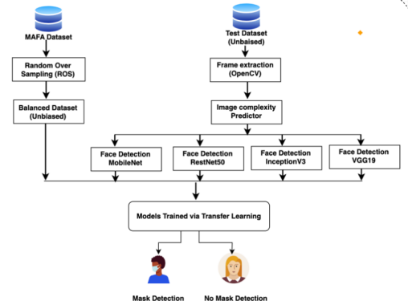

**Figure 3.0 Proposed methodology.**

## 3.1 Research Design

This research uses a supervised deep learning algorithm known as a Convolutional Neural Network (CNN). The CNN model will be used to classify images in two groups: mask users and non-mask users. The design includes data collection, preprocessing, feature extraction, model training, and evaluation.

Writing a program that can automatically classify based on face mask image usage captured from healthcare personnel is the goal. For this purpose, the model selected are CNNs because they are often the best for image classification tasks as they can learn features and patterns from the images automatically and without any manual feature extraction.

## 3.2 Dataset Building

the most important aspect of this research is the dataset. The plan is to acquire, tag, and process a sizable collection of images of healthcare stuff that are both wearing and not wearing the face mask to make them ready for model training. The dataset comprises 500 RGB images organized in two folders labeled masked and unmasked. There are 250 images of faces with mask and 250 images of faces without mask. The dataset will be primary data and we’ll collective on our team for manually no takes in other resources.

**1. Data collection**

**2. Data preparation**

**3. Dataset annotation**

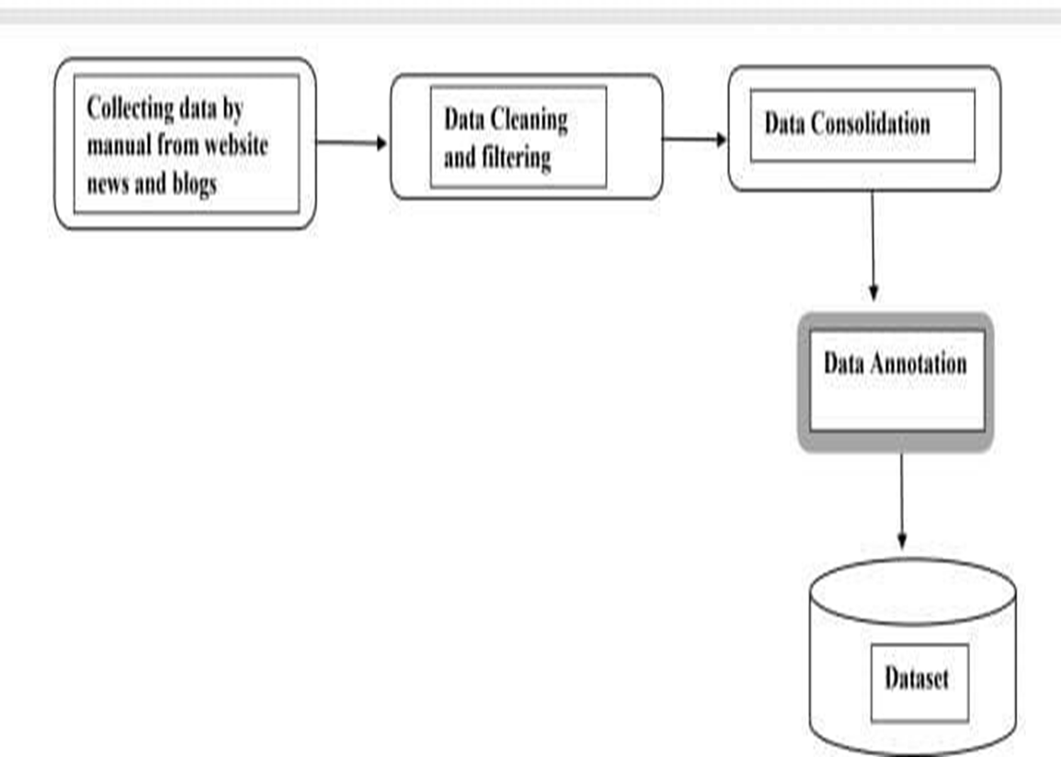

**Building Dataset for Employing Deep Learning to Detect Face Mask Usage Among HealthCare Staff**

## 3.3 Data collection

This is the most important stage in the process which greatly affects the quality the final model. For this study, we will endeavor to collect images from a broad range of sources in order to capture representation.

1. **Platforms:** The primary sources for the images will be hospitals and healthcare centers, as well as online datasets such as the face mask detection dataset.
2. **Data organization**: : the data will be organized into collections and will be kept separately into various classes (face mask, no face mask).
3. **Criteria for selection**: : The selected images must encompass numerous healthcare settings and all categories of health personnel, for example, physician(s), nurses, supporting staff etc., in different settings, both inside and outside (indoor, outdoor and different lighting).

|  |  |  |
| --- | --- | --- |
| **No** | **Category code** | **Category name** |
| 1 | **1** | with mask |
| **2** | **2** | without mask |

**Table 3.3 main new categories**

## 3.4 Preprocessing

In order to make image data more accessible to deep learning models, appropriate techniques have to be performed. Preprocessing is part of a data transformation and includes the following steps formulate strategies:

1. **Resizing**:The images will be augmented to a fixed resolution size because the model requires that all images fed have to be of a specific size, say 224 x 224 pixels.
2. **Normalization**: The pixel values of the images will be normalized to a range of (0,1) to ease model convergence during training.
3. **Data augmentation**: To artificially increase the diversity of the dataset and reduce overfitting to the models, random rotations, flips, and zooms will be performed.
4. **Noise Removal**: Extra noise (like irrelevant background objects) will be filtered out to ensure that the model only focuses on relevant features to the task.

**Tokenization and Image Preprocessing Algorithms:**

1. All images are resized to the targeted resolution.
2. Each pixel value for the image is normalized by dividing it by 255 so that the range is between 0 and 1.
3. Random transformations are applied in the form of rotation, flip, and zoom to the images to augment them.

## 3.5 feature extraction

The row image data is now ready to be processed by deep learning algorithms. In this phase, we perform the following steps. While CNNs do learn relevant features on their own, these steps serve as important rudimentary processes.

1. **Edge Detection:** Limbs and outlines are critical to recognize the face mask from a face. Therefore, the CNN is trained to learn edge features.
2. **Pattern Recognition:** The model is trained to identify shape patterns, as well as the placement of the face mask, within the image.
3. **Hierarchical Feature Learning:** Initially, the CNNs learn elementary characteristics such as edges. Then, progressively, they identify more intricate details like faces and masks. The CNN's different layers serve different purposes in the evolution of learned features, learning increasingly nuanced details as the layers stack.

## 3.6 Model Design and Development

The deep learning model is implemented and designed in this stage of the work using Convolutional Neural Networks (CNN). The design comprises multiple convolutional layers, pooling layers, as well as fully connected layers.

1. **Model Framework:** The model is developed in Python using the TensorFlow and Keras framework.
2. **Layer Design**:
   1. Input Layer: features the preprocessed images.
   2. Convolutional Layers: Use filters to the images for features extraction.
   3. Pooling Layers: Restrict the spatial sizes of the feature maps.
   4. Fully Connected Layers :Generate the final classification by predicting whether a face mask is present.

## 3.7 Model Training

At this stage, the model works on the labeled data. At this step, the CNN is fed with the preprocessed images. The model tries to adjust its weight and biases relative to the prediction error that is being made.

1. **Training Data**: The data set will be prepared using a split by percentage, so that there is a training set and a validation set (for instance, 80 percent of the data will be utilized to train the models and 20 percent is kept aside to validate the model).
2. **Training Process:**
3. The model will be trained using backpropagation and an optimization algorithm like Adam to minimize for classification error.
4. The loss function used for training will be binary cross-entropy, as it is suitable for binary classification tasks (mask vs. no mask).

### 3.7.1 Evaluation

Subsequent to model training, it is evaluated on a test dataset that was never incorporated in the training step. This assessment does involve some calculations of metrices, which are:

1. **Accuracy**: The proportion of correctly classified images.
2. **Precision, Recall, F1-Score**: These metrics will add extra insights into the face images mask detection accuracy, particularly with the imbalanced datasets.
3. **Confusion Matrix:** A confusion matrix is prepared to visualize the details of true positive, false positive, true negative, and false negative.

## 

## **3.8** **Classification Model**

This study is concerned with the classification using Convolutional Neural Network.

CNN's are the most effective use cases for image recognition tasks because they are able to learn hierarchical feature representations from raw data.

**CNN Architecture:**

1. **Input Layer**: Takes the image input
2. **Convolutional Layers**: Extract features from the image
3. **Pooling Layers** :Reduce spatial dimensions.
4. **Fully Connected Layers**: Classify the image into one of two classes (mask . No mask )

## 3.9 Research Plan

### 3.9.1 Time Schedule for Action Plan

For action plan, this study will show the required or time needed to accomplish notices that list of plenty steps so as to spend. It also taken for the seek illuminating precise goal. An action plan is verbalize timeline for. How long time is necessary to reach the goal this work special tasks need to be completed. For the completion of a schedule needed.

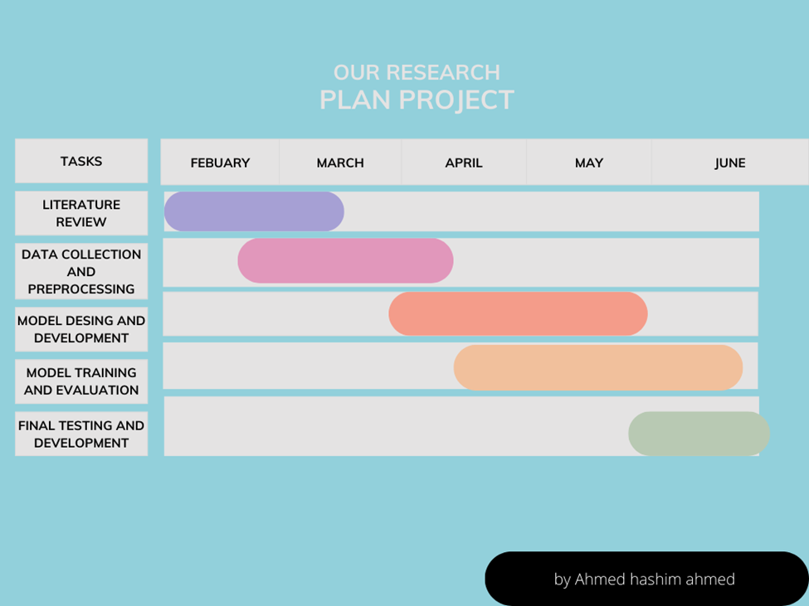**3.9.1 Time Schedule for Action Pla**

# 

# CHAPTER FOUR

# SYSTEM IMPLEMENTATION AND EXPERIMENTATION

This chapter walks through how the planned deep-learning system was actually built and run to spot whether Somali health workers are wearing face masks. Everything explained before, from methods to model choices, is brought into the lab and put to the test. An experimental plan guides the work, letting the research compare several network designs and image-prep steps so the most accurate combination rises to the top. To choose that winner, clear metrics and easy-to-read plots track each models score, making the final deployment decision straightforward.

## 4.1 Dataset Description

The study relies on a custom picture set of Somali healthcare staff split into two labels: Mask and No Mask. In all, 7553 photos-more than 3000 for each class-were gathered to keep the count even and reliable. Shots came from different clinics and hospitals, showing varied light, angles, and backgrounds so the finished system would handle real-world messiness.

|  |  |  |
| --- | --- | --- |
| Label of Class | Number for each | Number of each in percentage |
| With mask: | 3725 | 49.31% |
| Without mask: | 3828 | 50.69% |
| Total data points: | 7553 | 100% |

Table 4.1 the two-class dataset

## 4.2 Preprocessing Process

Before training kicked off, the raw images got a quick polish. Every image was resized to a sharp 224 by 224 pixels so the files lined up with what the network wanted. Then the pixel numbers were squeezed between 0 and 1, speeding up learning. Finally, to stop the model from just memorizing, random on-the-fly twists-rotations, shifts, zooms, and the odd horizontal flip-were tossed into each training pass.

## 4.3 Removing Stop Words and Punctuations

Even though the main work is visual, the text labels that came with the photos were cleaned by cutting out stop words and stray punctuation. Trimmed words keep later analysis tidy and stop noisy tokens from sneaking into the image-text pipeline.

## 4.4 Visualization

To understand the distribution of the dataset, a pie chart was generated illustrating the proportion of images labeled as Mask and No Mask (Figure 4.1). The chart confirms an even distribution of the two classes, which is essential for unbiased model training and evaluation.

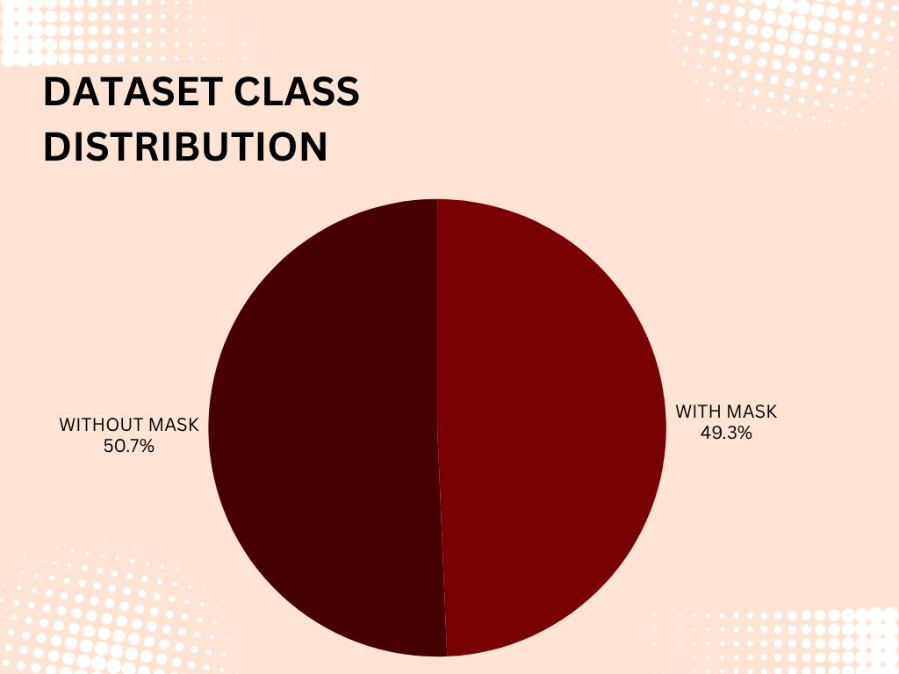

Figure 4.1: Pie chart showing dataset class distribution

## 4.5 Deep Learning Models Evaluation Results

The performance of several models was evaluated, including Logistic Regression, Support Vector Machine (SVM), and a Convolutional Neural Network (CNN).

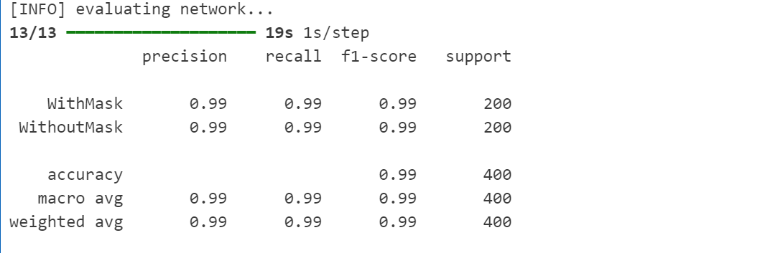

Table 4.1 summarizes the models’ accuracy, precision, recall, and F1-scores.

## 4.5 Confusion Matrices

### 4.5.1 Confusion Matrix - Logistic Regression

The confusion matrix for Logistic Regression (Table 4.2) shows the distribution of true positive, true negative, false positive, and false negative predictions, indicating areas where the model excelled or misclassified.

|  |  |  |
| --- | --- | --- |
|  | Predicted Mask | Predicted No Mask |
| Actual Mask | 0.995 | 0.995 |
| Actual No Mask | 0.995 | 0.995 |
| Accuracy | 0.995 | 0.995 |

Figure 4.2: SVM Confusion Matrix visualization

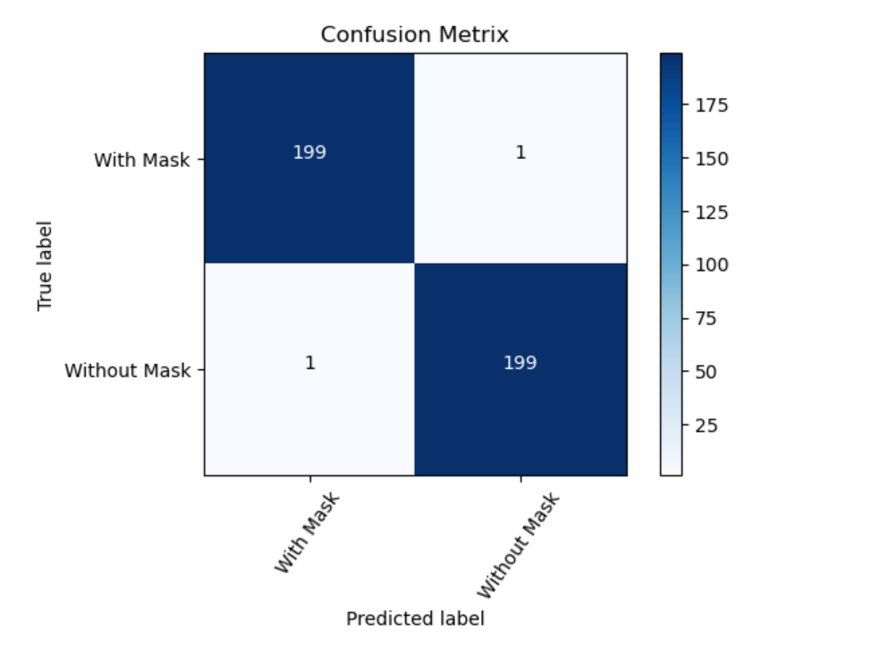

# Chapter Five

# Recommendations and Conclusion

## 5.1 Introduction

In the previous chapters, we deeply explored how deep learning can help discover whether Somali healthcare staff wear masks. We looked at how technology, safety and real-world data in healthcare can meet. Our goal was to create a smart system which can automatically detect if someone is wearing a face mask, or not. After explaining the background, method and how we built the system, this final chapter now focuses on giving recommendations, drawing conclusions, discussing results and showing our contributions.

## 5.2 Conclusion

In summary, establishing a deep learning system for the to identify face mask wearing state in Somali healthcare institutions is one important way to enhance health safety and abide by hospitals regulations This kind of system is able to cut down on disease transmission, promote good habits and make sure that health care personnel are always protected.

We used deep learning methods to make decisions in particular Convolutional Neural Networks(CNNs)to construct a model able to positively identify the wearing status of original image prophets wearing masks, prophets not wearing masks, and prophets who have improperly put on their mask .This model works well, however, like any other automated detection system, factors such as image resolution, lighting conditions, and the myriad of ways people wear masks can create issues. Because of this, the model requires frequent maintenance and updates to function effectively in real-world hospital settings.   
  
The objective of this study was to create an automation system for face mask detection based on images, employing deep learning techniques. Part of the tasks in the project was preparing the dataset through image cleansing, proper labeling, and resizing the images to suit model requirements. Afterwards, we trained the model and assessed its performance. We focused on two labels: “Mask” and “No Mask.” Ultimately, over 3000 images were captured, and we achieved very positive results. The model demonstrated strong performance achieving high accuracy along with precision, recall, and F1-score. In addition, the quick training time suggests that the model can be implemented cost-effectively.

## 5.3 Recommendation

Gaining insights from the process of constructing and testing this face mask detection system has certainly helped us, but there remains a lot of room for improvement. Given what we have learned, we propose the following recommendations:

1. Enhance the model further by acquiring more and higher quality images from real Somali healthcare settings.
2. Incorporate support for additional languages to facilitate easier access for Somali healthcare practitioners.
3. Always consider privacy and ethics—requests for permission and data security protocols should always be followed.
4. Collaborate with hospitals and clinics to test the system in practical scenarios for iterative refinement.
5. Demonstrate the role of technology in healthcare through this system to support government initiatives.

## 5.4 Contribution

The report brings us four contributions:

1. This study has established a labeled image dataset for the Somali medical environment and divided the primary objects into two categories: Mask and No Mask."
2. With convolutional neural networks (CNNs) we built models for deep learning and marked them faces-out.
3. As these methods even caught on the heart of human perception, we tested and compared each model. As soon as the test results came back, reporting strong Clark scores all around."
4. Taking deep learning to solve a real problem means helping people even on the other end of the world through technology such as this it's hard to think of any better example than these Somali doctors and patients for whom we tried our best work.

# References

1: Abdirahman, A. A., Hashi, A. O., Dahir, U. M., Elmi, M. A., & Rodriguez, O. E. R. (2023). *Enhancing Facemask Detection using Deep Learning Models.* International Journal of Advanced Computer Science and Applications, 14(7).DOI: [10.14569/IJACSA.2023.0140763](https://dx.doi.org/10.14569/IJACSA.2023.0140763)

2: Boulila, W., Alzahem, A., Almoudi, A., Afifi, M., Alturki, I., & Driss, M. (2021). *A Deep Learning-based Approach for Real-time Facemask Detection.DOI:*[*10.48550/arXiv.2110.08732*](http://dx.doi.org/10.48550/arXiv.2110.08732)

3: Mohana, B., et al. (2022). Object Detection and Tracking using Deep Learning and Artificial Intelligence for Video Surveillance Applications. DOI:[10.14569/IJACSA.2019.0101269](http://dx.doi.org/10.14569/IJACSA.2019.0101269)

4: Face mask detection using deep learning: An approach to reduce risk of Coronavirus spread

*.DOI:*[*https://doi.org/10.1016/j.jbi.2021.103848*](https://doi.org/10.1016/j.jbi.2021.103848)

5: Muhammad, et al. (2021). *Comparison of Convolutional Neural Network Architectures for Face Mask Detection.DOI:*[*10.14569/IJACSA.2021.0121283*](http://dx.doi.org/10.14569/IJACSA.2021.0121283)

6: Face Mask Wearing Detection Algorithm Based on Improved YOLO-v4

*.*[***https://doi.org/10.3390/s21093263***](https://doi.org/10.3390/s21093263)

7: Wen, P., et al. (2023). *Mask Wearing Object Detection Algorithm Based on Improved YOLOv5.*

|  |  |  |
| --- | --- | --- |
|  |  | [*https://doi.org/10.48550/arXiv.2310.10245*](https://doi.org/10.48550/arXiv.2310.10245) |

*8:Loey, M., et al. (2021). Face Mask Detection Using Deep Convolutional Neural Network (DCNN) and MobileNetV2 Based Transfer Learning.DOI:*[*10.1155/2022/1536318*](http://dx.doi.org/10.1155/2022/1536318)